 | International Civil Aviation Organization  WORKING PAPER
  NSP/6-WP/09
  Nov/2020
NAVIGATION SYSTEMS PANEL (NSP)

JOINT WORKING GROUPS – FIFTH MEETING

Virtual, Nov 2-13, 2020

Agenda Item XX:

Validation Material for GAST D E_{IG} to exceed 2.75m
Presented by Tim Murphy

Prepared by
IGM ad-hoc

SUMMARY
ICAO Annex 10, Appendix B, section 3.6.7.3.4 prohibits the GBAS ground station from transmitting parameters representing the residual ionospheric error that will cause E_{IG} to exceed 2.75m for any threshold supported by GAST D. WP19 of JWGs4 (Apr 19) explained why there would be significant benefit in allowing E_{IG} to exceed 2.75m for some individual runway ends that are located far away from the GBAS reference point.

In October 2019, JWGs5 WP42 was presented in order to justify and propose a change to ICAO Annex 10, to allow the GBAS GAST D residual ionospheric error, E_{IG} to exceed 2.75 m for individual thresholds at an airport. The paper suggested revised wording for Appendix B, section 3.6.7.3.4, and associated guidance material to support GBAS availability simulations. JWGs5 WP50 was also presented to close the action to confirm there is no impact to airworthiness criteria by allowing E_{IG} greater than 2.75 meters. WP08 for this meeting proposes revised wording for the SARPs as a maintenance change to allow E_{IG} to exceed 2.75m only when operational requirements permit.

Action 234 was taken on by the IGM ad-hoc group to do sensitivity analyses looking at the relationship between ionospheric models, distance to runways, E_{IG} and availability. This paper summarizes the results of sensitivity analyses supporting Action 234 for validation of the changes proposed in WP08 for this meeting. A high sensitivity of the maximum E_{IG} to threat models and airport size is shown, while a reasonable availability is demonstrated as feasible for many locations in the world for E_{IG} greater than 2.75 meters.

Action by the NSP to consider this paper as validation material to support the proposed maintenance changes from WP08 from this meeting is requested in Section 3.
- INTRODUCTION
ICAO Annex 10, Appendix B, section 3.6.7.3.4 prohibits the GBAS ground station from transmitting parameters representing the residual ionospheric error (M_{EIG and} Y_{EIG}) that will cause the largest undetected error due to an ionospheric gradient, E_{IG}, to exceed 2.75m for any threshold supported by GAST D. JWGs/4-WP/19 and JWGs/5-WP/42 and –WP/50, as well as WP08 at this NSP/6 develop motivation and proposed SARPs maintenance to allow an exception to this limit where operational requirements such as availability can be met.
GWG Action 234 confirmed the GWG agreement that this was a desired maintenance change for the SARPs for GBAS GAST D to enable flexibility of siting and implementation, pending an assessment of the sensitivity of availability and Landing Threshold Point (LTP) to GBAS distance to larger E_{IG} values. This working paper provides discussion and results from such sensitivity analyses, which is proposed for acceptance as validation material for the maintenance changes in WP/08.
- Discussion
  - Sensitivity of LTP to GBAS distance versus E_{IG}.
JWGs/4-WP19 provided an example realistic relationship between E_{IG} and LTP distance from the GBAS reference point for the SARPs mid-latitude ionospheric anomaly threat model, reproduced in the figure below for convenience. This relationship, or sensitivity, shows that E_{IG} would be required to be up to about 3.7 meters for LTP at a distance, D = 7km from the reference point.

Figure 1: Example Relationship between E_{IG} and the Distance, D, between GBAS Reference and Runway Threshold
For increased ionospheric anomaly threat spaces, the E_{IG} vs. D relationship may be steeper, which would result in larger E_{IG} versus D. For example, E_{IG} is less than 2.75 meters for a GBAS to LTP distance of about 5.1km with the existing ionospheric anomaly threat model, while a different threat model may result in E_{IG} of 2.75 at a smaller distance, D. Additionally, different ground station designs could mitigate ionospheric anomalies and result in reduced E_{IG} vs. distance to a degree. To illustrate the sensitivity of the distance at which EIG can be 2.75 meters versus the ionospheric threat model, simulation results for three scenarios are summarized for one ground station design as follows:

- ~5km – ICAO Standard Ionosphere Threat Model with maximum 500 mm/km gradient
- ~4km – ICAO Standard Ionosphere Threat Model with maximum 600 mm/km gradient
- ~3km – Ionosphere Threat Model based on Asia Pacific region observations
These are examples based on simulation results provided in the attachment material. This material was generated by Indra Navia using the same methods and simulations used to validate the GAST D SARPs for the standard threat model. It is apparent that if the ionosphere threat space increases over the years with more observations, and for equatorial regions like the Asia Pacific region, there can be a multiple kilometer difference in the siting flexibility for GAST D stations.
To illustrate the potential utility of allowing EIG to be larger than 2.75 meters, JWGs/4-WP/19 gave several examples of airports where runway thresholds are separated by large distances. If a GBAS is to be sited anywhere on the airport property, then the largest GBAS distance to a threshold can be estimated to be the maximum threshold separation. And, to support all runway ends, the shortest GBAS distance to a threshold must be greater than half that value, which assumes that the GBAS can be sited at the mid-point between those thresholds. In reality, the GBAS must be sited somewhere in between.
The table below explores runway threshold separations for the largest 15 airports in 2018 by surface area and the maximum LTP to LTP distances as a proxy for the maximum GBAS to LTP distances. While the worst case GBAS to LTP distance may be often avoided through careful siting, in many cases, even a fraction of the maximum will be greater than 5.1 km, still resulting in a need for E_{IG} greater than 2.75 meters. Furthermore, since the ionosphere threat may be greater for equatorial regions, the distance at which 2.75 meters E_{IG} is reached will be closer to 3 km, which is already less than half the largest distance for Shanghai Pudong International Airport. This indicates that without an E_{IG} greater than 2.75 meters, there may be no place for a single GBAS to be located that could serve all runways at some airports.
 | Airport | Country | Geomagnetic Latitude | Largest Distance  LTP to LTP or  GBAS to LTP (km)
1 | King Fahd International Airport | Saudi Arabia | 21.02N | 5
2 | Denver International Airport | United States | 47.45N | 8.4
3 | Dallas/Fort Worth International Airport | United States | 41.2N | 7.8
4 | Orlando International Airport | United States | 37.56N | 5.4
5 | Washington Dulles International Airport | United States | 48.14N | 6.1
6 | George Bush Intercontinental Airport | United States | 38.43N | 5.6
7 | Shanghai Pudong International Airport | China | 21.84N | 7.2
8 | Cairo International Airport | Egypt | 27.26N | 6.7
9 | Suvarnabhumi Airport | Thailand | 4.25N | 5.2
10 | Paris Charles de Gaulle Airport | France | 50.36N | 7.1
11 | Madrid Barajas Airport | Spain | 41.90N | 7.2
12 | O'Hare International Airport | United States | 32.84N | 5.9
13 | Salt Lake City International Airport | United States | 47.56N | 4.9
14 | Amsterdam Airport Schiphol | The Netherlands | 53.18N | 8.9
15 | Frankfurt Airport | Germany | 50.36N | 6.4

  - Sensitivity of Availability of GAST D versus E_{IG}.
Given that there is a significant sensitivity of E_{IG} to the ionosphere threat model, as well as to the LTP distance for a given threat model, the sensitivity of GAST D availability to an increased E_{IG} must be validated.
An availability analysis was performed for GAST D, varying E_{IG} and the airborne geometry screening parameter maxE_{V}. maxE_{V} is the maximum allowable vertical error that an aircraft automatic landing system may be demonstrated to meet all airworthiness criteria for successful landing, which is ensured regardless of the E_{IG} value through satellite geometry screening in the airborne receiver. An analogous limit in the lateral exists but has a negligible impact on availability for the same limit as the vertical. The analysis also shows that the availability of protection levels less than their alert limits is also negligible as E_{IG} and maxE_{V} are varied. Details of the analysis and assumptions are provided in an attachment to this paper.
Figure 2 shows results from that analysis in the form of global availability maps for varying E_{IG} and maxE_{V}. These maps assume today’s 31-satellite constellation with every combination of up to 3 satellites removed with probabilities as follows, called RTCA Probabilities: 1-out=3%, 2-out=1.2%, and 3-out=0.8%. Any color on the map indicates less than 99.9% availability for that location with these assumptions. 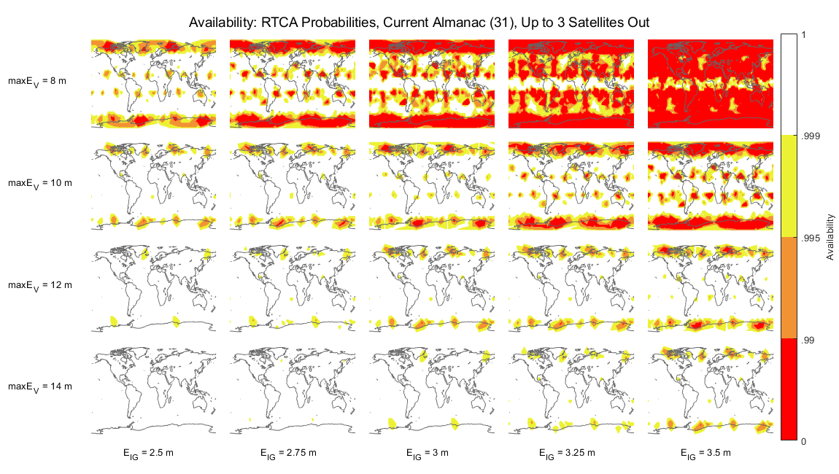
Figure 2: Current Availability of GAST D versus E_{V} and E_{IG}
With the exception of a few high latitude locations, 99.9% availability is achieved for maxE_{V} greater than 10 meters and E_{IG} less than 2.75 meters. For maxE_{V} smaller than 10 meters, availability is significantly reduced, regardless of E_{IG}, while E_{IG} greater than 2.75 meters has a more gradual impact, and E_{IG} as high as 3.5 meters is demonstrated to achieve more than 99.9% availability for a large portion of the world.
Figure 3 shows a slight reduction in availability but similar results for the expanded 27-slot GPS configuration using the same satellite outage probabilities, rather than using the full 31- satellite constellation enjoyed today. For E_{IG} up to 2.75 meters and maxE_{V} 10 meters or greater, global availability exceeds 99.9% in most places. For maxE_{V} less than 10 meters, even for EIG less than 2.75 meters, the availability is much lower in much of the world.
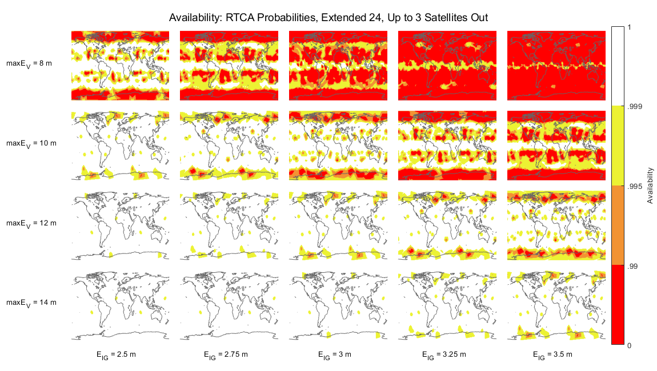
Figure 3: 27-Slot GPS Configuration Availability of GAST D versus EV and EIG
These results indicate that for E_{IG} up to 2.75 and airborne geometry screening parameters E_{V} and E_{L} greater than or equal to 10 meters availability of 99.9% is achieved almost everywhere. This indicates that GAST D availability prediction may not be needed for most of the world unless the GPS constellation is reduced to a 24-slot configuration.
The results also indicate that many locations could support 99.9% availability with E_{IG} greater than 2.75, even as high as 3.5 meters or more, although the constellation assumptions and airborne geometry screening begin to limit availability in some locations.
Even with the current limit on E_{IG} of 2.75 meters, if an airborne manufacturer requires E_{V} and E_{L} less than 10 meters, then the availability will be significantly impacted and the airborne operator should be required to predict their availability, regardless of E_{IG}. Such a requirement would allow an air navigation service provider to assume a minimum E_{V} and E_{L} in predictions of availability for a particular GAST D approach to ensure availability. This could allow E_{IG} much larger than 2.75 meters to have assured availability through the use of NOTAMs when the minimum assumed airborne user is considered since users below this minimum would have to assure their own availability for E_{IG} regardless of the E_{IG} for the approach.
While the constellation assumptions and simulation specifics may vary depending on the details of the GBAS installation and approach operation, and while the specific minimum airborne geometry screening limits that may require a user prediction could be decided elsewhere, these results indicate that there is a large amount of usable system availability that would be wasted if E_{IG} were to continue being limited to 2.75 meters.

- ACTION BY THE meeting
  - The meeting is invited to:
- Review the contents of this paper
- Consider this paper as validation material supporting the NSP/6-WP/08 proposal to update the requirement in ICAO Annex 10 Volume 1 Appendix B section 3.6.7.3.4 and to also include associated guidance material in Attachment D in an upcoming amendment.

— END —

